Getting Started

First of all you will need to have accounts with at least one bookmaker which has horse racing events from around the globe

For the latest free bet offers for global racing please visit the page below:

Click Here for Free Bets

If you are from the USA, you can still use the system and we would recommend you bet at TwinSpires as you can bet legally on racing here.

Copyright 2020 Midas World Racing, all rights reserved.

Unauthorised duplication or distribution without the express
permission of the copyright holder, contravenes applicable laws.
Please note that all information is provided ‘as is’ and no guarantees are given whatsoever as to the amount of profit you will make if you use this system. Neither the author of this system, the publisher or any affiliates can be held responsible for any profits or losses from following this information, all betting involves an element of risk and you should never bet with money you cannot afford to lose.

Please Gamble Responsibly 18+
Introduction

i.
Before we get started, I’d just like to take this short moment to thank you for investing in Midas World Racing.
I’m extremely confident that you’ll experience a great deal of success if you
follow these strategies. However a pattern I see is that many people will go
out of their way to invest in betting systems but rarely take the action to put
them into good use.

My advice to you would be to start off small and begin slowly until you’ve gained complete confidence in this system, then from there it’s really just a matter of scaling it up to harness its full power.

But like any kind of gambling or betting, I ask you to gamble responsibly
and to make smart, informed decisions when using the strategies outlined
in the report. Never play with money you can’t afford to lose. While I hope you fully succeed with these methods I cannot take responsibility for future results as with any form of gambling things can go wrong.

With that said, I wish you all the best with this method. Now, let’s get started.
Let’s get into it!

The following methods are the real deal! They’ll have losing days, but a day or two later up pop 2 or 3 winners at and it’s BANG back into form again.
1
I’m confident that the following information will put a lot of money in your account over the coming months and years and a smile on your face. Enjoy!
With these systems you’ll be looking at horse races around the globe using betting forecasts to either pick horses the market is confident in or finding horses of value.
I don’t care where you are in the world or what race you want to bet on. UK, Ireland, USA, Australia or Hong Kong. This system works as long as you have access to a betting forecast on the race.
The systems utilises obvious information that’s available for anyone to see.
We have both our Midas World Racing system and the Value World Racing system that give two approaches for you to profit with.
With the Midas system we focus on very fancied horses that are in the race to win.
Aren’t ALL horses in a race trying to win? Fortunately for us, no they’re not It’s estimated that in any given race, a minimum 20% of the horses are running with absolutely no intention of trying to win. They’re NOT running to their true ability. Shrewd connections are running them at an unsuitable distance, the wrong going or surface and are “laying them out” for a gamble for a certain race that can be months away.
Without “inside information” that is only available for the privileged few and is never advertised how do we find the correct horse to back?
2
The answer is to Follow the Market and find what is a “Gambled on” horse. Money is placed on these horse in large amounts which shortens the prices for us to spot and to take advantage of.
But that is not the only approach we are going to take. There’s two systems in this PDF: One that follows the market. One that bets against.
Now before you think I’m a crazy. Yes we can both bet with the market and against the market and show profit in both systems. They are not mutually exclusive.
These systems are not complicated and armed with a pencil and calculator you can quickly get your selections together in 15 minutes for the day.

The Midas World Racing System
3
To utilise any of the systems in this manual you need some movement in the market for us to be able to place a bet that has moved away from the forecast price.
With the Midas World Racing system our formula is designed to follow money placed on horses by those in the know so we can find the best horses without having to do research.
Whilst you can bet at any time I would suggest around 2 hours before the first race on the racecard you are studying for the Midas World System.
However for the Value World Racing System you can use any time you like.
The reason I suggest this is I’ve personally found the price crashes too much close to the start of racing for the Midas System and the bookies have sussed which horses are being overbet and shortened the price too much.

System Instructions
Step 1: Find a reliable Betting Forecast.
A betting forecast is simply what the horses predicted odds are, this is NOT the bookmaker odds but a price calculated by horse racing sites usually based on complex mathematically algorithms to determine who is most likely to win the race. If you’re very smart you can even create your own betting forecast.
My favourite forecasts are listed below, but really any reliable forecast price will work with the method.
UK/IRE Racing - Racing Post Forecast (at bottom of the racecard) - Found Here
USA Racing - Twinspires Profit Line (on racecard as PL) - Found Here
Australia, Hong Kong, Japan and rest of the world - Racing and Sports (forecast on racecard as PP in $ amount - this is effectively decimal odds) - Found Here
Important Note: You do not need an account with any of these websites you can access all the forecast prices for free without any signup.

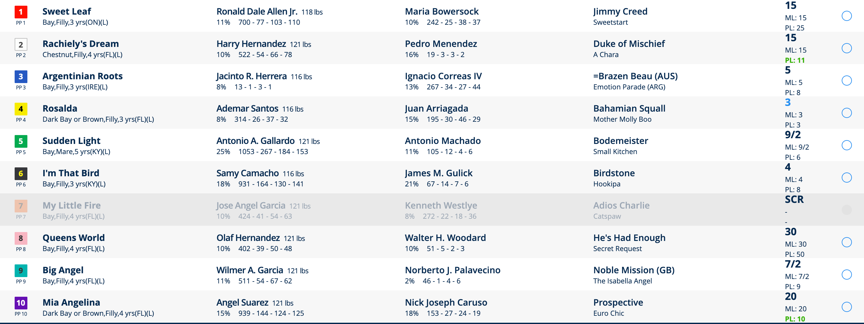
Here is a screenshot of the profit line price on Twinspires. To find click “Bet Now” tab then click “Today’s Races”

On the right side of racecard you see in small text PL: 25 for the first horse Sweet Leaf. PL stands for Profit Line and means the first horse is forecast at 25/1 and the second at 11/1.
This is your first reference point.
Step 2: Compare Forecast Odds to Oddschecker Odds
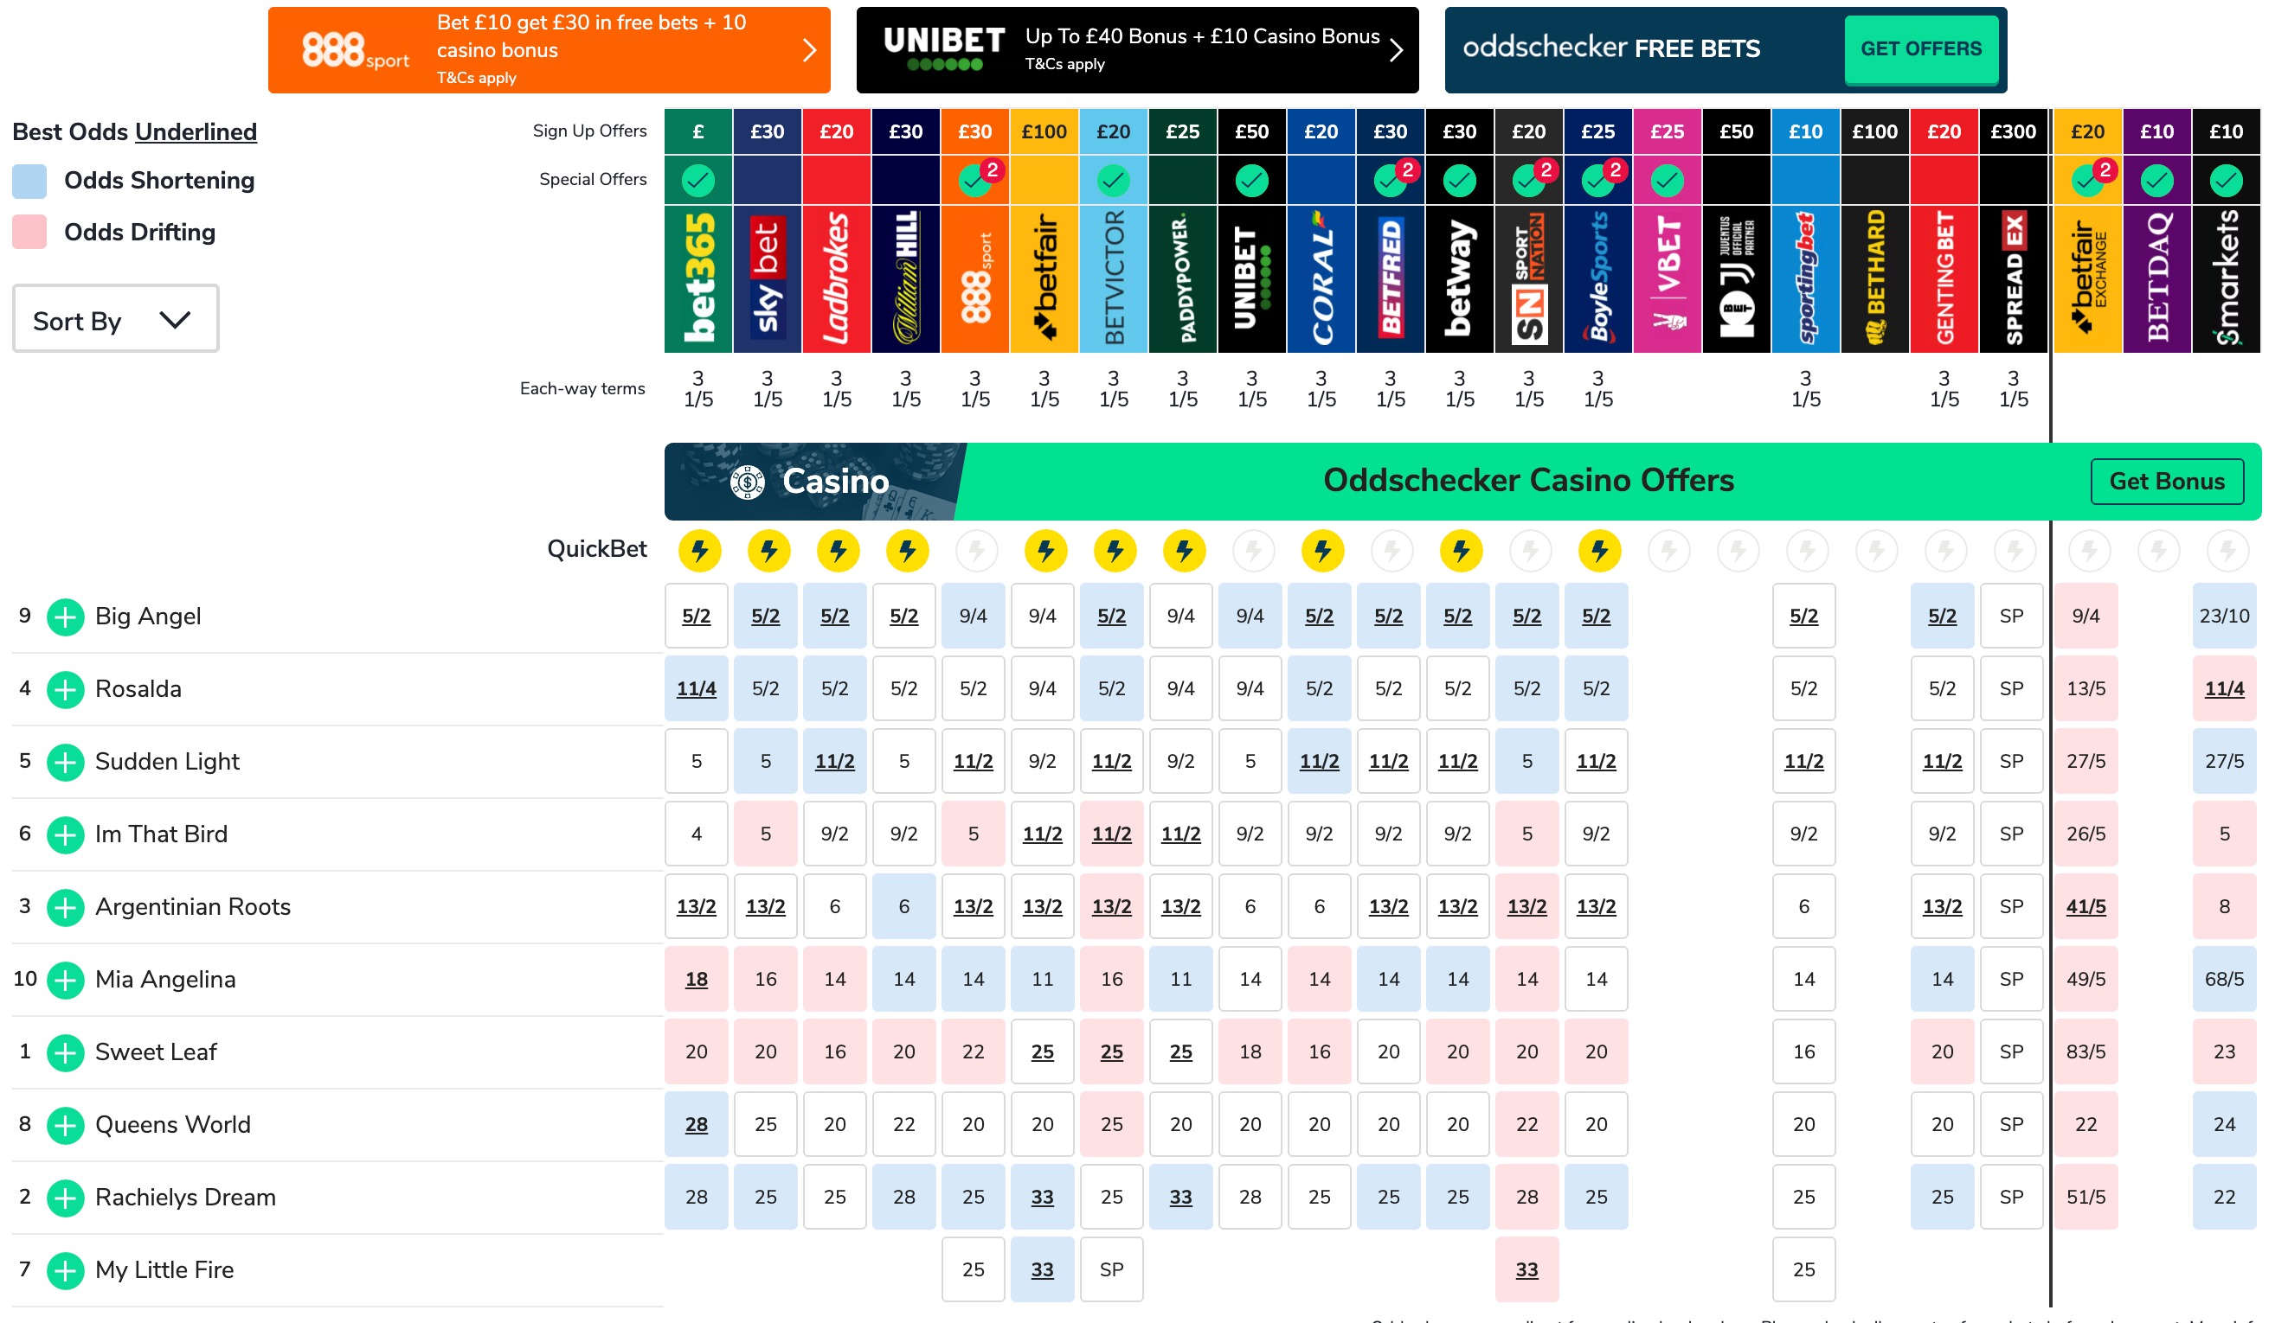
Next its time to open up your bookies site or oddschecker.com to find out the horses current price. Here is how the same race looks on Oddschecker.

Now when comparing prices between our forecast and actual odds we need to follow these rules.
Rule 1. Only Focus on Top 3 Horses on Oddschecker or Your Bookie
There are two reasons we are doing this. Firstly it takes a long time to assess all horses in each race so by focusing on the top 3 we can quickly find selections. Secondly and most importantly a lot of outsiders wildly jump in price, particularly over 20/1 and the forecast prices can be less reliable.
So the above 3 horses we will be assessing will be Big Angel, Rosalda and Sudden Light.
Rule 2: Look for an odds drop greater than 40% from the Twinspires PL price to the Oddschecker price.
6
Now I know what your thinking how the hell do I calculate that?
The simplest way is to convert the odds to a number to do this simply divide the two numbers in the odds price.
E.g. 2/1 = 1 or 5/1 = 5 or 5/2 = 2.5
If using decimal odds you simply take off 1 off the number.
Example: For our 3 horses we can quickly discount Sudden Light and Rosalda as these haven’t dropped over 40%.
For the favourite Big Angel there is a big drop from 8/1 to 5/2, this is obviously more than 40% and qualifies, but I will show you how to work out the exact percentage drop.
To work out what a 40% decrease in price would look like we simply divide 8 (from 8/1) by 100 and multiply the number by 60. This equals 4.8 or 48/10 (5.8 decimal odds) as a fraction meaning anything less than this is a qualifier.
I’m using best odds on Oddschecker, but you can use the bookie you bet with. As the best odds are 5/2 we use this odds number. To calculate exact drop use the following formula…
Oddschecker Odds/Forecast Odds - 1 * 100 = Percentage drop.
For our example this is:
2.5/8 - 1 * 100 = 68.75%
This means it definitely qualifies as it well before our 40% rate as a bet we should back.
Result - Big Angel Wins!
This is a BIG drop in price from the forecast and sure enough Big Angel wins at 5/2.
Rule 3: Do not back if 2 qualifiers in top 3
As the other two horses didn’t qualify we were safe to back, but to save points I would recommend skipping any races that throw up 2 qualifiers in the top 3.

Rule 4: Ignore races with significant non-runners
If a fave pulls out the race we will obviously have a big odds crash. We don’t need to worry about a non-runner at odds above 10/1, but non runners below this price and multiple non-runner can affect prices.
Rule 5 (Optional): Ignore drops greater than 70%
Although the horse in our example won I wouldn’t have wanted any bigger of a drop as it starts to call into question how accurate the forecast is, rather than how well supported the horse is. Cutting off anything above 70% will help limit these sorts of problems.
This is an optional rule for extra safety and can be left out if you want an easier system to follow.

The Value World Racing System

As well as the Midas World Racing System that focuses on backing horses strongly fancied by the market we also have a very good way of backing horses at a value price.

This is a completely different approach for those who can put up with a lower strike rate, but really appreciate value in the odds price and wants to profit this way.
System Instructions
Step 1: Find a reliable Betting Forecast.
As with the Midas World Racing System my favourite forecasts are listed below, but really any reliable forecast price will work with the method.
UK/IRE Racing - Racing Post Forecast (at bottom of the racecard) - Found Here
USA Racing - Twinspires Profit Line (on racecard as PL) - Found Here
Australia, Hong Kong, Japan and rest of the world - RacingandSports.com (forecast on racecard as PP in $ amount - this is effectively decimal odds) - Found Here
Reminder: You do not need an account with any of these websites you can access all the forecast prices for free without any signup.
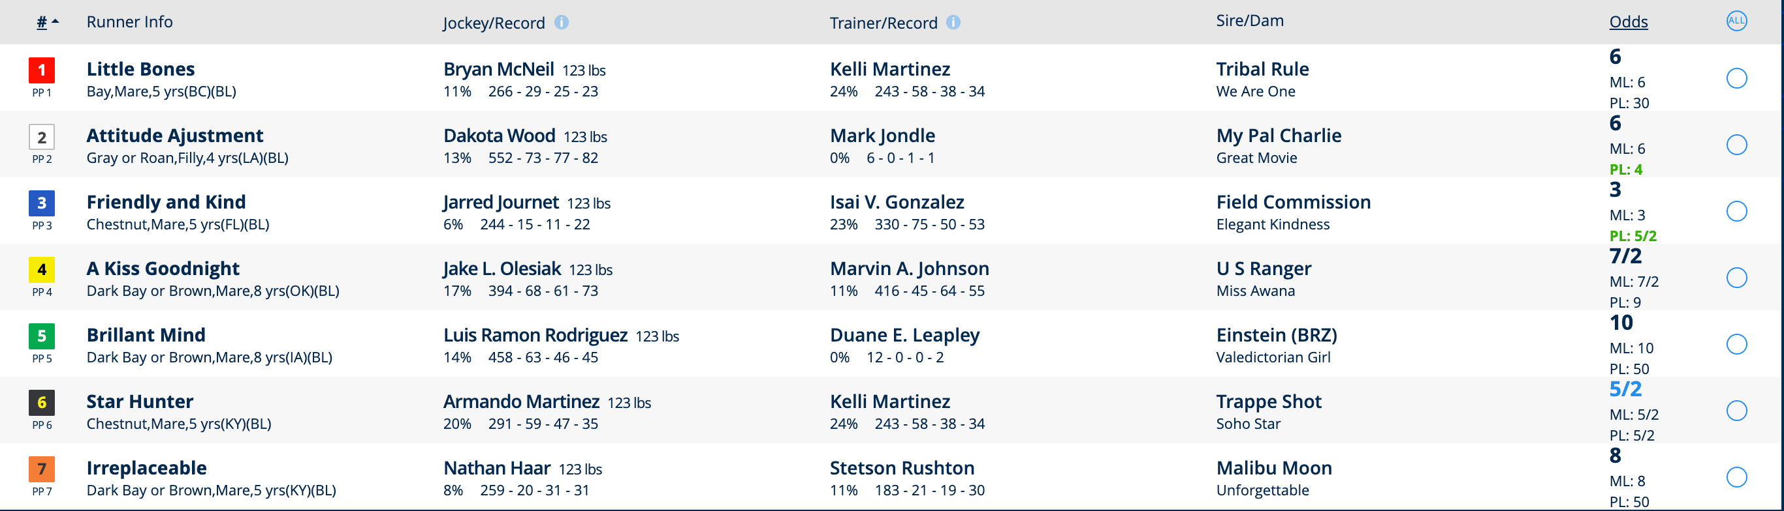
Here is an example of a Twinspires racecard we can obtain our betting forecast from. This is for the 00:15 race at Fonner Park.

Step 2: Compare Forecast Odds to Oddschecker Odds
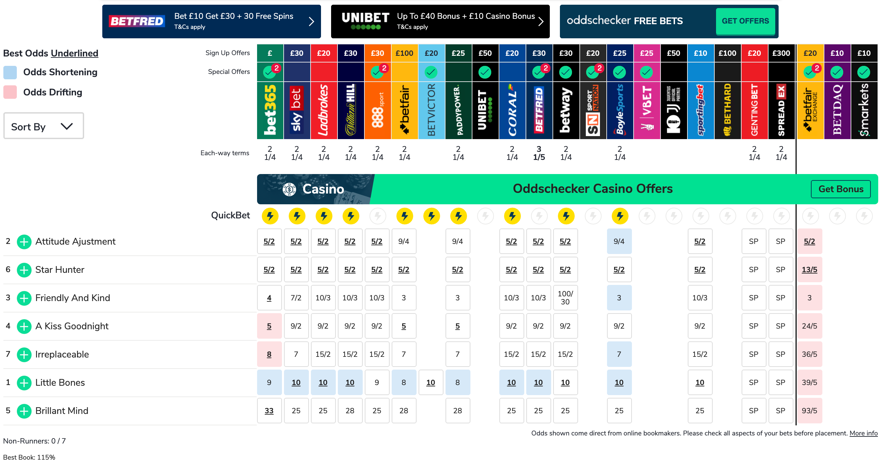
Next its time to open up your bookies site or Oddschecker.com to find out the horses current price. Here is how the same race looks on Oddschecker.
When comparing prices between our forecast and actual odds we need to follow these rules.
Rule 1. Only Focus on Top 3 Horses on Oddschecker or Your Bookie
There are two reasons we are doing this.
Firstly it takes a long time to assess all horses in each race so by focusing on the top 3 we can quickly find selections.
Secondly and most importantly a lot of outsiders wildly jump in price, particularly over 20/1 and the forecast prices can be more unreliable on the bigger price horses.
So the above 3 horses we will be assessing will be Attitude Adjustment, Star Hunter and Friendly and Kind
Rule 2: Look for an odds increase greater than 30% from the Twinspires PL price to the Oddschecker price.
6
Now I know what your thinking how do I calculate that?
The simplest way is to first convert the odds to a number to do this simply divide the two numbers in the odds price.
E.g. 2/1 = 2 or 5/1 = 5 or 5/2 = 2.5
If using decimal odds you simply take 1 off the number.
Example: For our 3 horses we can quickly discount Attitude Adjustment and Star Hunter as Attitude Adjustment has dropped in price and Star Hunter has remained at exactly the same price.
For the third favourite Friendly and Kind there is an odds price of 5/2 on the PL (Profit Line) price and a price of 4/1 as best odds on Oddschecker, to work out if it qualifies we can quickly do the following formula.
PL / 100 x 130 = 30% increase
5/2 = 2.5 / 100 = 0.025 x 130 = 3.25
This means anything above 3.25/1 or 4.25 decimal odds is above 30%. As 4/1 or 5.0 is above this it qualifies.
You can use best odds as your marker on Oddschecker if you can bet at that particular bookie, if not you will need to use the odds of the bookie you can bet at.
To work out the exact odds increase you can use the following formula.
Oddschecker Odds/Twinspire PL Odds = 4/2.5 = 1.6 - 1 = .6 = 60% increase in odds.
Result: Friendly and Kind wins!
Our method has correctly spotted a well priced horse, the SP of the horse was 2/1, meaning that our 4/1 was great value!
Rule 3: Do not back if 2 qualifiers in top 3
As the other two horses didn’t qualify we were safe to back, but to save points I would recommend skipping any races that throw up 2 qualifiers in the top 3.
Rule 4 (Optional): Ignore Qualifiers above 60%
Our horse scrapes into qualifying with a 60% increase in odds. Although most bookies priced the horse at 10/3 which would have been just a 33% increase and closer to our lower limit so in my opinion this was a good bet particular at the best odds bookie.
The reason for including an upper limit is generally if something looks too good to be true it usually is. If an evens horse drifts to 10/1, do we really think we have discovered that much value? It’s unlikely.
Although on the same card at Fonner Park I had earlier dismissed Perfect Line who I found on Oddschecker at 7/2, but was a PL price of 2/1 as it was too high at a 75% odds increase. Frustratingly it won at 7/4 SP.
So this is why this is an optional rule as it will cut off some winners along with the losers it throws out.
Value World Racing System Example 2
Just so it’s crystal clear on what you are supposed to do here is another example from the Will Rogers Down racecard
Step 1: Obtain the forecast
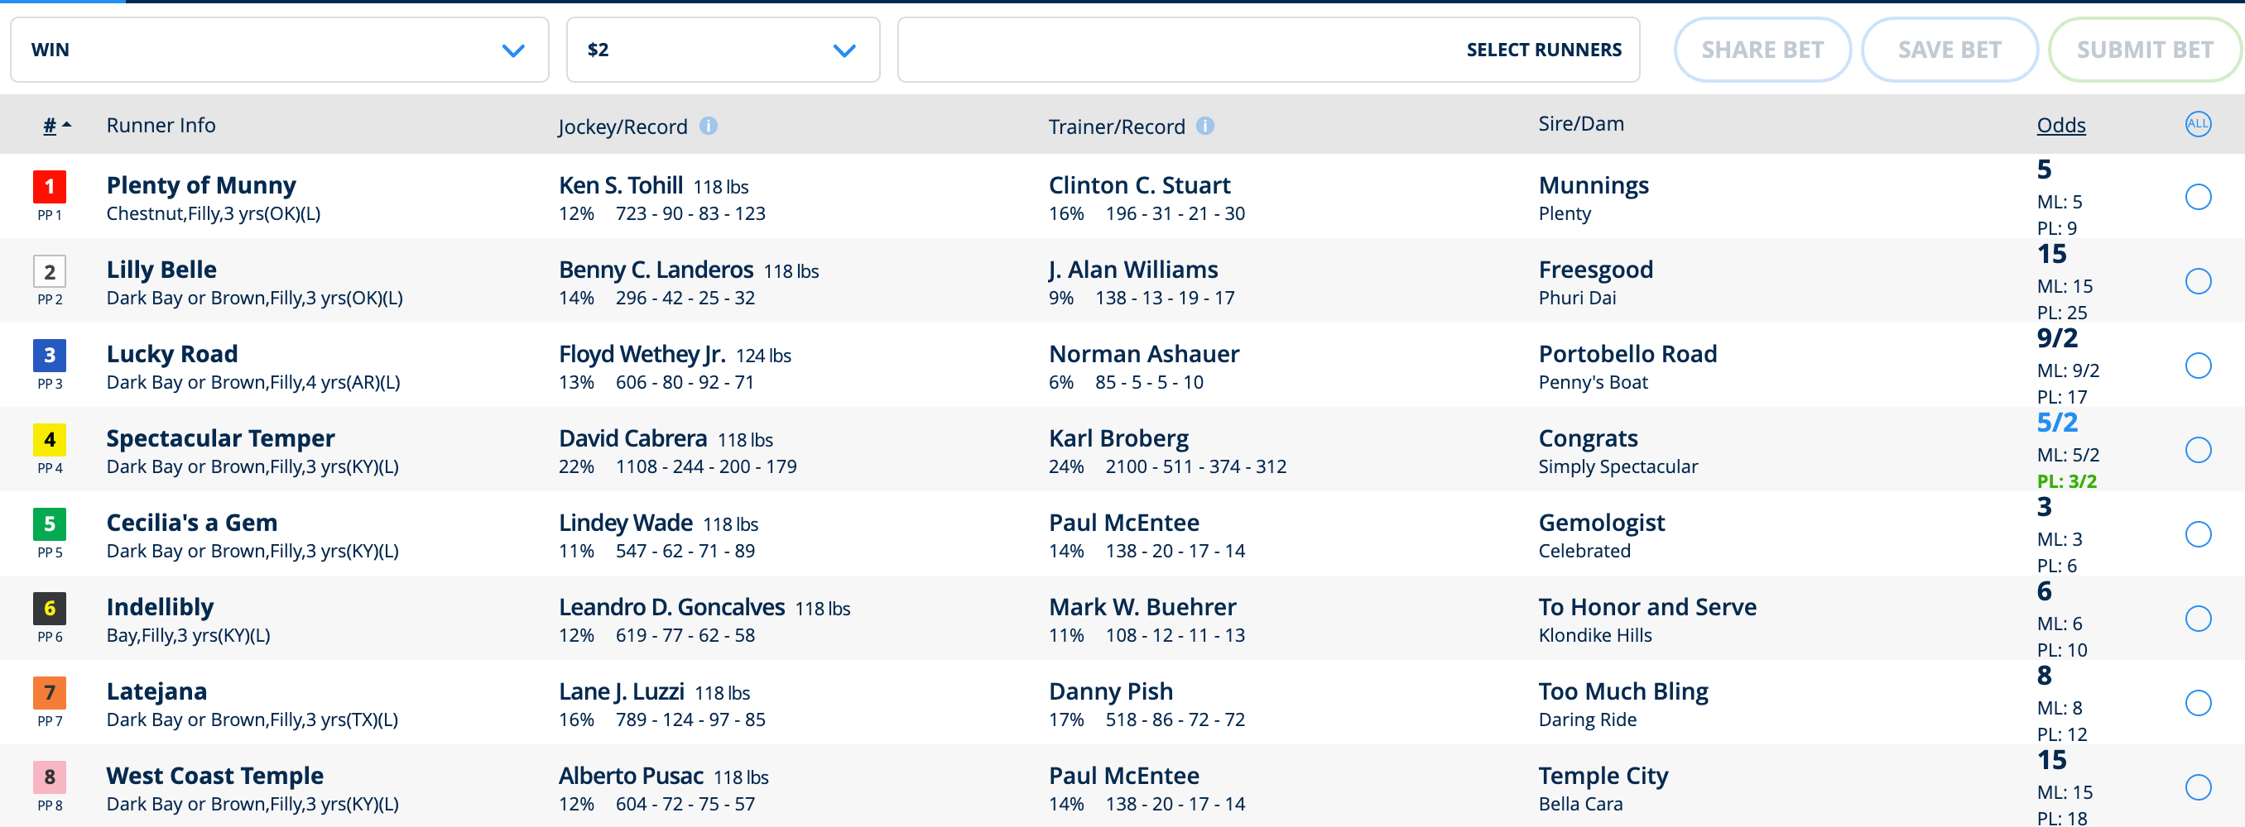
USA Racing - Twinspires Profit Line (on racecard as PL) - Found Here

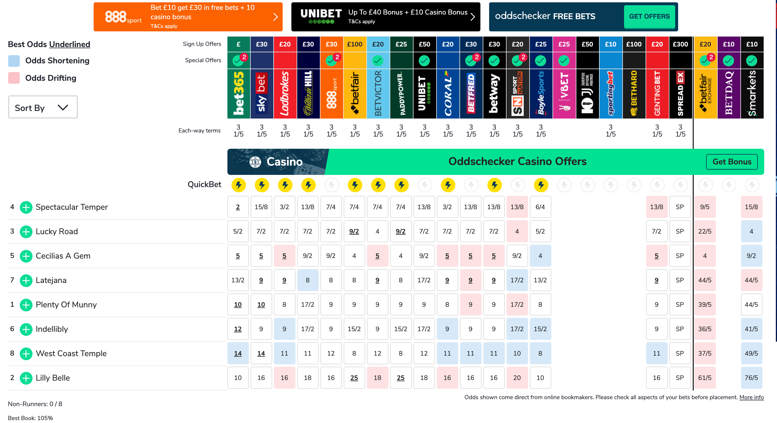
Step 2: Compare Forecast Odds to oddschecker.com Odds

Rule 1. Only Focus on Top 3 Horses on Oddschecker or Your Bookie
So the above 3 horses we will be assessing will be Spectacular Temper, Lucky Road and Cecilias A Gem.
Rule 2: Look for an odds increase greater than 30% from the Twinspires PL price to the Oddschecker price.
For our 3 horses we can quickly discount Lucky Road and Cecilias A Gem as they have dropped in price.
For the favourite Spectacular Temper there is an odds increase from 3/2 (6/4) on the PL (Profit Line) price to 2/1 at the best odds bookie, to work out if it qualifies we can quickly do the following formula.
PL / 100 x 130 = 30% increase
3/2 = 1.5 / 100 = 0.015 x 130 = 1.95
This means anything above 1.95/1 or 2.95 decimal odds is above 30%. As 2/1 or 3.0 (best price of horse on odds checker) is above this it qualifies.
You can use best odds as your marker on Oddschecker if you can bet at that particular bookie, if not you will need to use the odds of the bookie you can bet at.
To work out the exact odds increase you can use the following formula.
Oddschecker Odds/Twinspire PL Odds = 2/1.5 = 1.33 - 1 = .33 = 33% increase in odds.
Result: Spectacular Temper wins!
Our method has correctly spotted a well priced horse, the SP of the horse was 8/11, meaning that our 2/1 was great value!
Never let anyone tell you a fave can’t be good value!
Rule 3: Do not back if 2 qualifiers in top 3
As the other two horses didn’t qualify we were safe to back, but to save points I would recommend skipping any races that throw up 2 qualifiers in the top 3.
Rule 4 (Optional): Ignore Qualifiers above 60%
Our horse was 33% so met this criteria easily.

Troubleshooting and Advice
Inevitably as this is horse racing and many variable affect results things will not always go so perfectly so here are some tips to help you with the system.
- Bet low stakes and increase only on profits
- Stick to 1 point bets
- If you wish you can vary the system according to odds. A couple of successful versions I’ve tested on UK racing are betting between 2/1 and 8/1 only and betting at 20/1 and below on all horses below 20/1 in odds. These versions use all horses not just top 3.
- If you wish to extend top 3 you can vary to top 2 for small fields (7 or less), 4 (16+), 5 (20+)
- Limit according to race types. E.g. if a race looks unpredictable we don’t have to bet on it. This is trial and error so it does require testing and helps if you know a bit about the races.
- Live version of systems. Bet just before the off to capture late money for the Midas System or a late drift for the Value System. This is an alternative technique for those who like to back through the race day as races occur.
Conclusion
7
11
I hope you’ve enjoyed reading The Midas World Racing System and the Value World Racing System. I wish you all the best for your future as a successful backer of horses.
Most importantly, take action on these strategies as they do work like gangbusters. And remember, bet responsibly.
Any doubts about a selection leave it alone. If you have a loser or two don’t
panic and begin to chasing your losses and only play with money you are
prepared to lose.
Good luck and all the best!
Steve G, Author
Midas World Racing

FAQ:
How much should I stake on each bet?

You can bet whatever you wish I would recommend starting at tiny stakes or paper trading to get an idea of how the systems work.

How much can I make with this system?

The sky’s the limit. You can make £1000s with this system, but make sure you bet with stakes you are comfortable with and bet responsibly.

Will I have losing days?

Yes almost certainly, but don’t worry you’ll also have lots of winning days, its important to give this system a good run, as if you stick with it the profitable days will come. If you are a cautious bettor, you can paper trade to learn the system patterns fully. Don’t be put off by a few losing days though, as this system bounces back from losses very well.

I don’t have the time to do both systems which is best?
12

Personally I prefer the Value System, that said the Midas system is very popular and has a higher strike rate.

My bookie doesn’t have horse racing how do I bet?
12

USA and International Players can still profit using Sportsbooks such as Twinspires, here you will be able to bet on a range of horse races around the globe.

What is the Racing Post Forecast?

If you go to the Racing Post and then view the race card for the race you want to bet on, you will see that at the end of the cards is the forecast odds for each horse, this is the racing post forecast. (see example below)
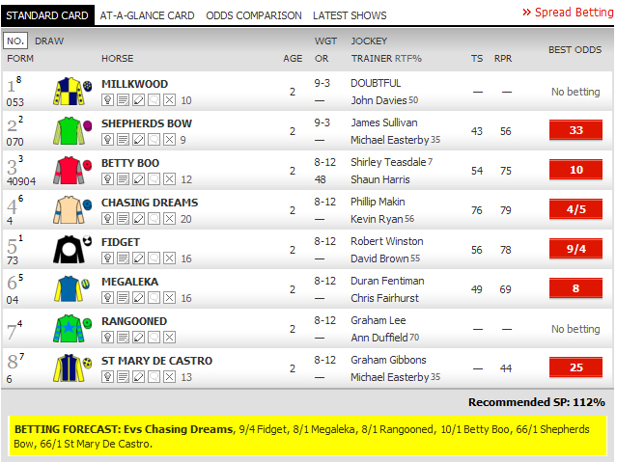
What is the Twinspires Profit Line?
13

As above this is a forecast price done using a computer program to determine the odds for each horse. It is the number next to PL on the racecard.

I’m struggling with the Maths of the Midas system can you help?
For the Midas System the easiest thing is to use this formula.
7/2 Odds Price
So 7/2 = 3.5
3.5 / 100 = 0.035
0.035 x 60 = 2.1
2.1/1 is the odds price that is 40% below the current price of 7/2. So as long as it is below 2.1/1 it will be under 40%.
I’m struggling with the Maths of the Value system can you help?
For the Value System you are looking for a 30% increase from the forecast price so use this formula.
Forecast price = 7/2
So 7/2 = 3.5
3.5 / 100 = 0.035
0.035 x 130 = 4.55
So anything above 4.55/1 is a 30% bigger increase

I need some further help with the system, can I contact you?
Of course! Simply email me your query to support@themidasmethod.net and I will assist you.

Copyright 2020 Midas World Racing, all rights reserved.

Unauthorised duplication or distribution without the express
permission of the copyright holder, contravenes applicable laws.
Please note that all information is provided ‘as is’ and no guarantees are given whatsoever as to the amount of profit you will make if you use this system. Neither the author of this system, the publisher or any affiliates can be held responsible for any profits or losses from following this information, all betting involves an element of risk and you should never bet with money you cannot afford to lose.

Please Gamble Responsibly 18+
14
14

